Project Design Phase-II
Data Flow Diagram & User Stories

Date
Team ID | SWTID-2026-6947
Project Name | AI FAQ Assistant API
Maximum Marks | 4 Marks

Data Flow Diagrams:
A Data Flow Diagram (DFD) is a traditional visual representation of the information flows within a system. For the AI FAQ Assistant API, the DFD shows how user and administrator requests pass through the Express.js API, authentication middleware, business logic, MongoDB/Mongoose data storage, and Google Gemini AI services.
DFD Level 0 – AI FAQ Assistant API
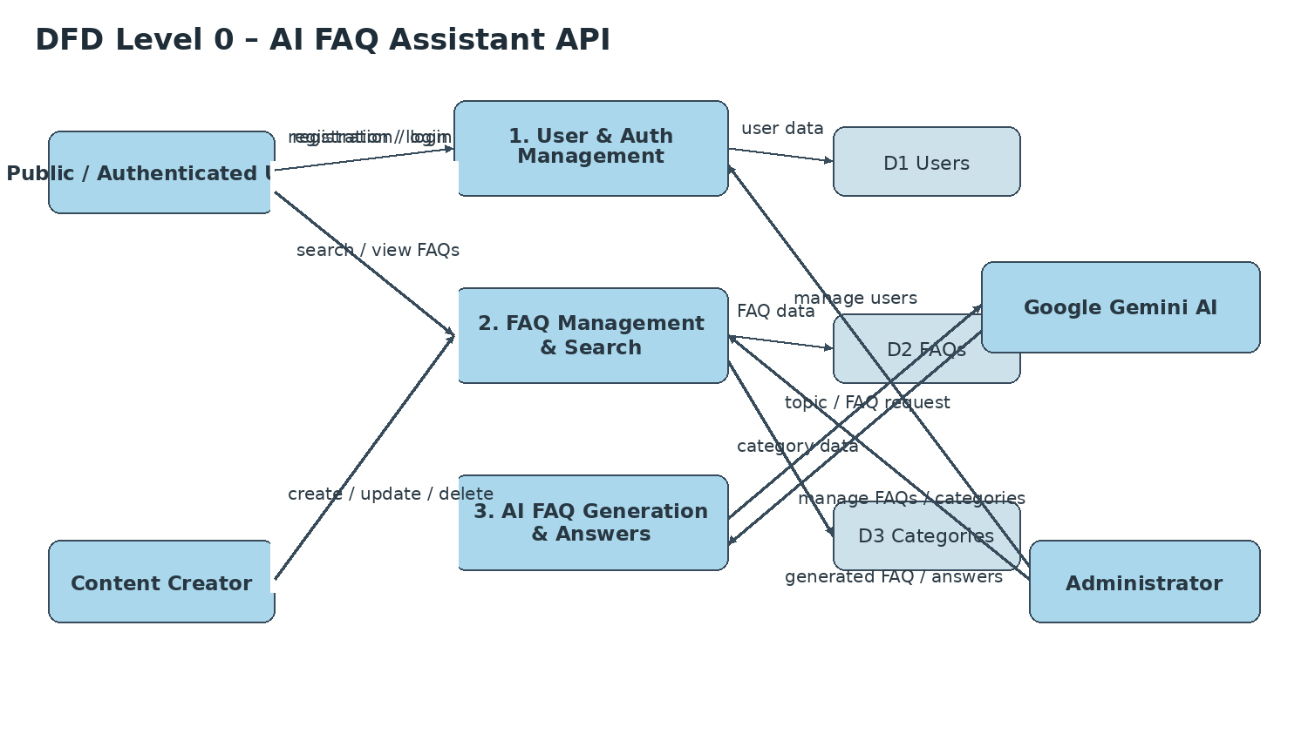
Simplified Data Flow – AI FAQ Assistant API
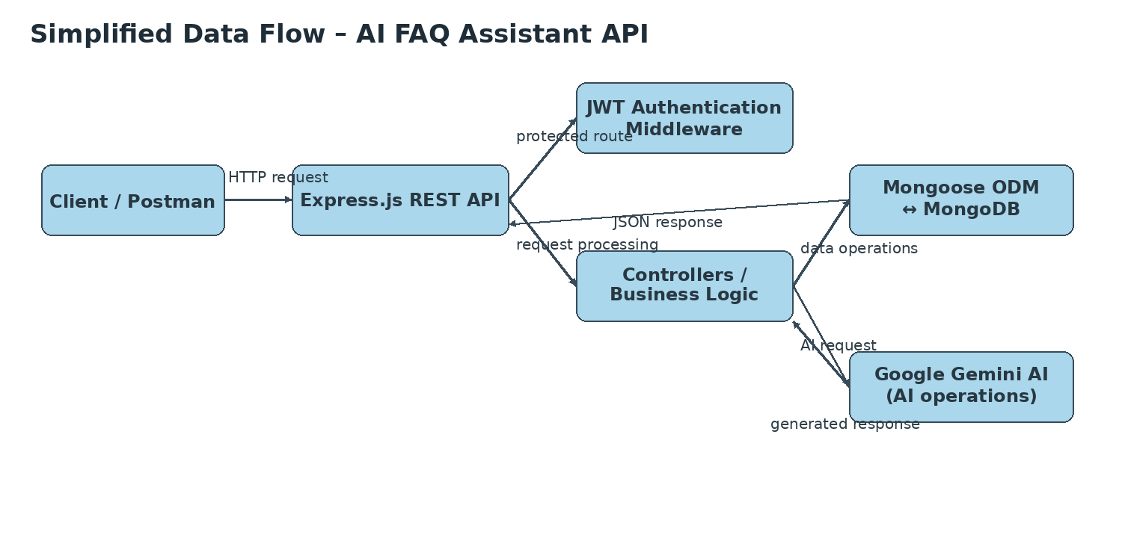

Documented flow represented in the DFD:
1. Client / Postman sends requests to the Express.js REST API.
2. Authentication middleware validates JWT tokens for protected routes.
3. Controllers / services process user, FAQ, category, and AI operations.
4. Mongoose communicates with MongoDB for user and FAQ data.
5. Google Gemini AI supports automated FAQ generation and AI-assisted question-answering.
User Stories
Use the below template to list the user stories derived from the documented roles, features, user flow, API operations, AI integration, and security requirements.
User Type | Functional Requirement (Epic) | User Story Number | User Story / Task | Acceptance criteria | Priority | Release
Public User | FAQ Viewing & Search | USN-1 | As a public user, I can view published FAQs. | Published FAQs are available for viewing. | High | Release-1
 | FAQ Viewing & Search | USN-2 | As a public user, I can search FAQs using keywords. | Keyword search returns relevant FAQ information. | High | Release-1
Authenticated User | Registration | USN-3 | As a user, I can register by providing my name, email, and password. | The API validates the request and returns a successful registration response. | High | Release-1
 | Login & Authentication | USN-4 | As a registered user, I can log in using my registered email and password. | The API returns a successful login response with user details after authentication. | High | Release-1
 | Profile | USN-5 | As an authenticated user, I can access my personal profile information. | Authenticated users can access their profile information. | Medium | Release-1
 | FAQ Viewing & Search | USN-6 | As an authenticated user, I can view public FAQs. | I can view published FAQ information. | High | Release-1
 | FAQ Viewing & Search | USN-7 | As an authenticated user, I can search FAQs using keywords. | I can search FAQs and retrieve relevant information. | High | Release-1
 | AI-assisted Answers | USN-8 | As an authenticated user, I can generate AI-assisted answers. | The system provides AI-assisted question-answering through the documented AI integration. | Medium | Release-2
Content Creator | FAQ Management | USN-9 | As a content creator, I can create a new FAQ. | An FAQ can be created with question, answer, category, and creator information. | High | Release-1
 | FAQ Management | USN-10 | As a content creator, I can view FAQ records. | I can retrieve FAQ information including question, answer, and category. | High | Release-1
 | FAQ Management | USN-11 | As a content creator, I can edit my FAQ records. | I can update my FAQ records. | High | Release-1
 | FAQ Management | USN-12 | As a content creator, I can delete my FAQ records. | I can delete owned FAQ records and receive confirmation of deletion. | High | Release-1
 | AI FAQ Generation | USN-13 | As a content creator, I can generate FAQs using AI. | Google Gemini AI can generate FAQ questions, answers, and topic suggestions from a given topic. | High | Release-2
 | Category Management | USN-14 | As a content creator, I can organize FAQs under categories. | FAQs can be organized under categories for easier management and retrieval. | Medium | Release-2
Administrator | User Management | USN-15 | As an administrator, I can manage all registered users. | The administrator can manage registered users. | High | Release-1
 | FAQ Management | USN-16 | As an administrator, I can view any FAQ. | The administrator can view FAQ records. | High | Release-1
 | FAQ Management | USN-17 | As an administrator, I can update any FAQ. | The administrator can update FAQ records. | High | Release-1
 | FAQ Management | USN-18 | As an administrator, I can delete any FAQ. | The administrator can delete FAQ records. | High | Release-1
 | Category Management | USN-19 | As an administrator, I can manage FAQ categories. | The administrator can manage FAQ categories. | Medium | Release-2
 | AI Content Monitoring | USN-20 | As an administrator, I can monitor AI-generated content. | The administrator can monitor AI-generated content. | Medium | Release-2
Authenticated User | Security & Access | USN-21 | As an authenticated user, I can access protected API routes after JWT validation. | Protected routes require valid authentication information. | High | Release-1
Administrator | Role-based Access | USN-22 | As an administrator, I can access complete system functionality according to my role. | Role-based access controls administrator functionality. | High | Release-2
Content Creator | Role-based Access | USN-23 | As a content creator, I can access FAQ creation and AI-generation functions allowed for my role. | Content creator responsibilities include creating FAQs and generating FAQs using AI. | High | Release-2
Developer / API Client | Validation & Errors | USN-24 | As an API client, I can receive standardized API responses when requests are invalid or errors occur. | Centralized error handling and Mongoose schema validation maintain data integrity and standardized responses. | Medium | Release-2

